SHARK TANK STARTUP INVESTMENT ANALYSIS

INTERNSHIP REPORT
A report submitted in partial fulfillment of the requirements for the award of the degree of
M.Sc. Data Science
Submitted by
L.VINTHIYAVASHINI
Reg.No: 24131025305722021

Under the Guidance of

Dr. K. VADIVAZHAGAN
Assistant Professor/Programmer

ANNAMALAIUNIVERSITY
FACULTY OF SCIENCE
DEPARTMENT OF COMPUTER AND INFORMATION SCIENCE ANNAMALAI UNIVERSITY-608002
JULY 2025

ANNAMALAIUNIVERSITY

FACULTY OF SCIENCE
DEPARTMENT OF COMPUTER AND INFORMATION SCIENCE
BONAFIDE CERTIFICATE
This certificate is issued for her internship training entitled “ SHARK TANK STARTUP INVESTMENT ANALYSIS”, which is the original work done by L.VINTHIYAVASHINI, (Reg.No: 24131025305722021) a student pursing M.Sc.,(Data Science) III Semester at Annamalai University during the academic year July 2025.

Signature of the Guide
Dr. K. Vadivazhagan

Internal examiner External examiner

Place: Annamalai Nagar
Date:

Head of the Department
DECLARATION
I, L. VINTHIYAVASHINI (Reg. No. 24131025305722021), M.Sc. Data Science III Semester student in the Department of Computer and Information Science, hereby declare that the internship training entitled “SHARK TANK STARTUP INVESTMENT ANALYSIS,” trained as a Data Scientist, is my own bonafide work, carried out with my personal effort under the supervision of Dr.K.VADIVAZHAGAN, Assistant Professor, Department of Computer and Information Science, Annamalai University.

Signature of Student
L.Vinthiyavashini

(24131025305722021)

Place : Annamalai nagar
Date :

ACKNOWLEDGEMENT
I would like to express my gratitude to our Dr. S. SRIRAM Dean, Faculty of Science, Annamalai University for his consistent support and encouragement throughout the programme.
I would like to express my gratitude to Dr.L.R.ARAVIND BABU, Head of Department of Computer & Information Science, Annamalai University for his consistent co-operation and encouragement throughout the programme.
I express my heartfelt thanks forever to my Internship co-ordinator Dr.S.SIVASUBRAMANIAM, Assistant Professor/Programmer, Department of Computer & Information Science, Annamalai University for encouragement, unfailing support and valuable criticism throughout my project work.
I express my heartfelt thanks forever to my Internship Guide Dr.K.VADIVAZHAGAN, Assistant Professor/Programmer, Department of Computer & Information Science, Annamalai University for suggesting this work, providing invaluable and untiring guidance, encouragement, unfailing support and valuable criticism throughout my project work.
I wish to record my sincere thanks to all our staff members working in the department, my friends and family members whose blessings made this task possible for me.

(L.VINTHIYAVASHINI)
TABLE OF CONTENTS
S.No | Title | Page  No
I | Information about the Company | 1
II | Information about the Internship Position and Description of Internship Experiences. | 2
III | Introduction | 5
IV | Objective  1.The Existing Process  2. Problem Statement  3. Methodology  4. The Process Design  5. Development  6. Deployment | 7  7  8  8  10  24  31
V | Summary | 32
VI | Conclusion | 33
VII | References | 34

- INFORMATION ABOUT THE COMPANY:
NextGen Solutions is a company that offers IT services and solutions, including programming courses, job placement support, and digital marketing services. They are based in Cuddalore, Tamil Nadu and also operate as an IT staffing services provider. The company is dedicated to providing comprehensive IT and digital solutions to businesses of all sizes.
Key Services:
- IT Training and Education:
NextGen Solutions provides programming courses and aims to equip individuals with the skills needed for the digital landscape.
- Job Placement Support:
They offer assistance to students in finding job opportunities.
- Digital Marketing Services:
The company provides digital marketing solutions to help businesses grow their online presence.
- IT Staffing:
NextGen Solutions offers IT staffing services, placing qualified professionals with companies.
- Technology Solutions:
They offer a range of technology solutions, including website development, email systems, and managed IT services.

II. INFORMATION ABOUT THE INTERNSHIP POSITION AND DESCRIPTION OF INTERNSHIP EXPERIENCE:
During my internship, I gained valuable experience that significantly enhanced my technical, analytical, and professional skills. I worked on a Shark Tank Startup Investment Analysis project, where I applied Python, Tableau, and machine learning to analyze real-world startup funding data.
The journey began with mastering Python and essential libraries such as Pandas, NumPy, Matplotlib, and Seaborn. I was responsible for cleaning and preprocessing the investment dataset, which taught me the importance of data consistency, handling missing values, feature engineering, and preparing structured datasets for analysis.
Next, I used Tableau to convert cleaned data into interactive dashboards, presenting insights on key factors like industry trends, city-wise funding, founder dynamics, and investor behaviour. This phase helped me understand how data visualization and storytelling can support better strategic decisions in the startup ecosystem.
The core project involved building a predictive model to estimate invested amounts in successful deals. I used features such as valuation, equity offered, number of founders, and funding gaps to train a linear regression model. I evaluated the model using metrics like R² score and split data for training and testing. This process deepened my understanding of how machine learning models can provide actionable insights for investment decision-making.

Collaboration was a key part of the internship. Working with mentors and other interns helped me improve my teamwork and communication skills. We shared ideas, solved challenges together, and received valuable feedback that refined our analysis and visualizations.
Throughout the internship, I also strengthened soft skills such as time management, adaptability, and critical thinking, especially while meeting deadlines, preparing reports, and presenting findings.
Overall, the internship was a transformative experience. It gave me hands-on exposure to data analytics tools and techniques and allowed me to work on a real-world, business-focused problem. This experience laid a strong foundation for my career in data science, business analytics, and startup research.

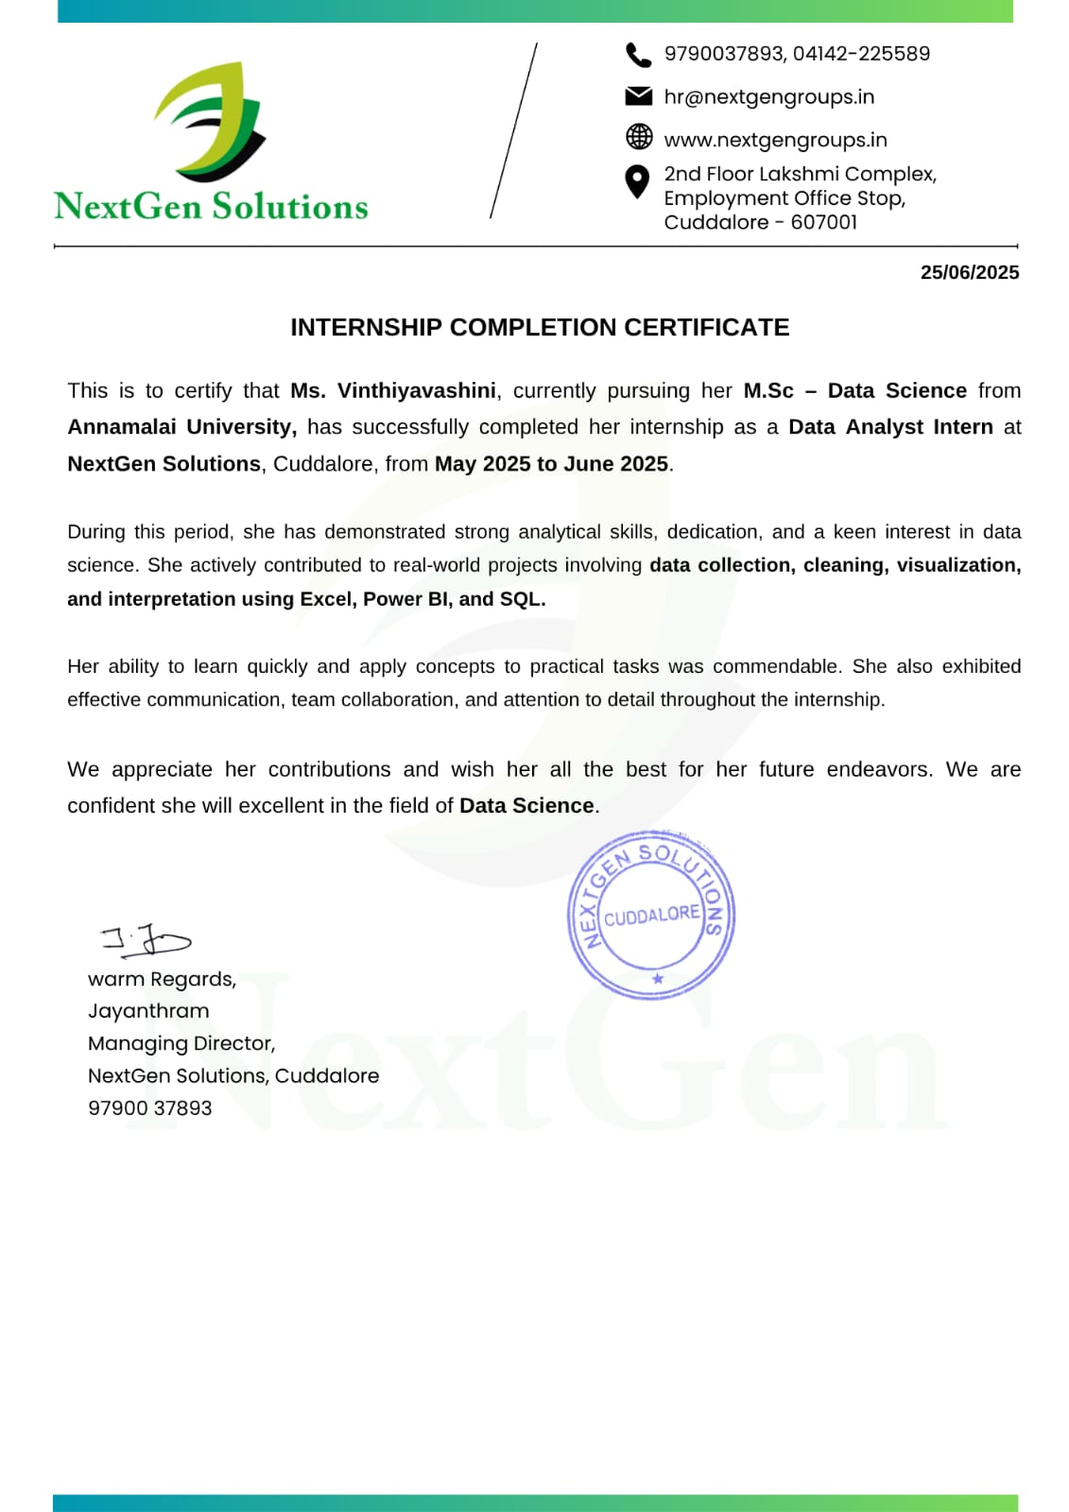

III . INTRODUCTION:

Python
Python is a high-level, general-purpose programming language known for its simplicity and versatility. It was used as the primary language in this project to perform data cleaning, feature engineering, statistical analysis, and machine learning modeling. Python’s extensive ecosystem of libraries made it ideal for working with structured startup investment data.
Pandas
Pandas is a powerful open-source data analysis and manipulation library for Python. In this project, it was used to load the dataset, handle missing values, remove duplicates, standardize text, and create new features such as founder count, funding gap, and funding fulfilment percentage.
Numpy
NumPy, short for Numerical Python, provides support for large, multi-dimensional arrays and matrices. It was used in this project to perform efficient numerical operations during feature calculations and data preprocessing.
Matplotlib & Seaborn
Matplotlib and Seaborn are popular Python libraries for creating static, animated, and interactive visualizations. They were used extensively to create charts and plots such as bar plots, count plots, and scatter plots, helping to uncover patterns across industries, cities, and equity distribution.

Scikit-learn
Scikit-learn (also known as sklearn) is a widely used machine learning library in Python. In this project, it was used to build a linear regression model for predicting the invested amount in successful startup deals. It also provided tools for splitting the dataset and evaluating model performance using metrics like R² score.
Tableau
Tableau is a powerful data visualization tool used to create interactive dashboards and present key insights in a user-friendly format. Cleaned data was exported and visualized in Tableau to explore startup trends by industry, city, founder count, and investment behaviour.
Google Colab
Google Colab was used as the coding environment for this project. It allowed for writing and executing Python code in the cloud, making it easy to collaborate, visualize outputs, and save results. It also supported the integration of various Python libraries required for analysis.
CSV
CSV (Comma-Separated Values) files were used to store and manage the dataset. The project involved importing raw data from a CSV file, cleaning it, and exporting the final structured data for further use in modeling and visualization.

IV. OBJECTIVE:

To analyze startup investment data inspired by Shark Tank India and create meaningful visualizations using Python and Tableau in order to uncover key funding trends, investor behaviour, and factors influencing deal success, thereby improving the understanding of startup funding patterns.
1.Existing Process :
Startup funding decisions, especially in platforms like Shark Tank India, have traditionally been based on subjective judgment by investors. These decisions rely on factors such as the founders’ pitch, product uniqueness, market potential, business model, and financials. While investors often consider valuation, equity offered, and founder background, the evaluation process is typically manual and varies from one investor to another. There has been limited use of data-driven methods to consistently analyze patterns in startup success or predict investment behaviour. With the growing availability of structured pitch data and advancements in data analytics, it is now possible to analyze historical funding trends and investor decisions using tools like Python and Tableau, enabling more objective, data-backed insights.

2.Problem Statement :
The objective of this analysis is to develop a data-driven approach to understand the key factors influencing startup funding decisions on platforms like Shark Tank India. The core challenge is to predict the invested amount in successful startup deals based on features such as valuation, equity offered, number of founders, and funding requested. Another challenge is identifying patterns in funding trends across industries, cities, and founder profiles. The goal is to assist entrepreneurs and investors in making informed decisions by uncovering insights that influence deal success, ultimately supporting more strategic investment behaviour and startup growth.

3.Methodology :
The project follows a structured data science workflow to analyze startup investment trends and predict investment outcomes. The methodology involves the following key steps:
- Data Collection:
Collected data from a Shark Tank India-inspired CSV file with details about startups, funding, equity, valuation, and deal status.
- Data Cleaning:
Cleaned the data by fixing missing values, removing duplicates, standardizing text (like city and industry names), and converting currency columns into numeric format.

- Feature Engineering:
Created new useful columns like number of founders, funding gap, funding percentage fulfilled, equity category (low/medium/high), and deal success flag.
- Outlier Handling:
Used the IQR (Interquartile Range) method to handle extreme values in funding, valuation, and equity columns.
- Exploratory Data Analysis (EDA):
Used graphs and charts to study trends by industry, city, year, equity, and investment patterns using Python libraries like Matplotlib and Seaborn.
- Model Building:
Built a Linear Regression model to predict the invested amount in successful deals using features like valuation, equity offered, and founder count.
- Model Evaluation:
Evaluated the model using R² score to check how well the predictions matched real investments.
- Dashboarding with Tableau:
Created interactive dashboards to visualize funding trends and deal patterns across industries, cities, and years.

4. THE PROCESS DESIGN :
FLOW CHART:

Data Loading and Exploration
- Load csv file using pandas
- Inspect data using info(),describe()

Handle Missing Values
- Fill missing investors/valuation info
- Replace with ‘No Deal

Feature Engineering
- Num_Founders, Funding Gap
- Funding Fulfillment%, Equity level

Outlier Handling (IQR)
- Cap extreme values for key features

Data Splitting
- Train – Test Split using sklearn

Train ML Model
- Linear Regression to Predict Funding

Evaluate Model
- $R^{2}$ Score, Visualization of Predictions

SOURCE CODE :
4.1 Data Loading and Exploration

import pandas as pd
import matplotlib.pyplot as plt
import seaborn as sns
from sklearn.model_selection import train_test_split
from sklearn.linear_model import LinearRegression
from sklearn.metrics import r2_score
from google.colab import files

#1. Load the dataset
df = pd.read_csv("sharktank_startup_investment.csv")
print(df.head())
print(df.describe())
print(df.shape)
print(df.info())

Output:

1.
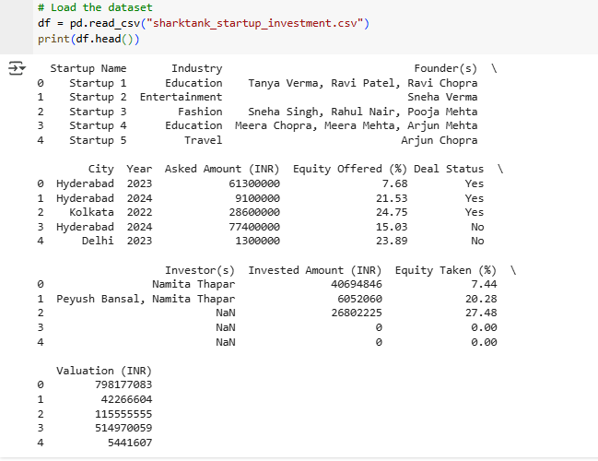
2.
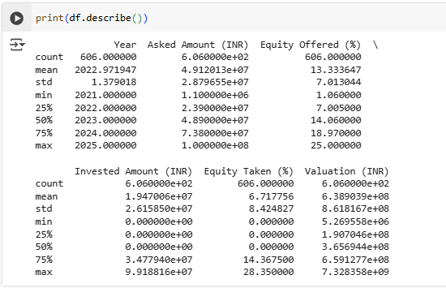

3.
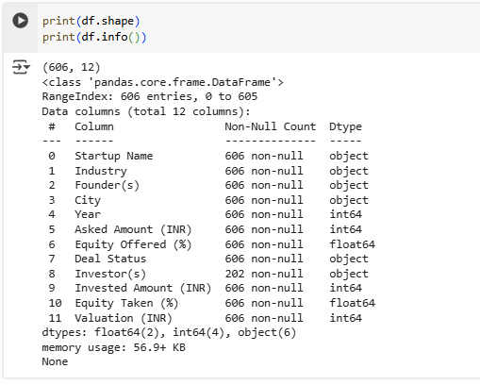

4.2 Data Cleaning :

# 2. Data Cleaning
df['Investor(s)'] = df.apply(lambda row: row['Investor(s)'] if row['Deal Status'] == 'Yes' else 'No Deal', axis=1)
df['Investor(s)'] = df['Investor(s)'].fillna('Unknown')
df['Industry'] = df['Industry'].str.strip().str.title()
df['City'] = df['City'].str.strip().str.title()
df['Deal Status'] = df['Deal Status'].str.strip().str.title()
amount_cols = ['Asked Amount (INR)', 'Invested Amount (INR)', 'Valuation (INR)']
for col in amount_cols:
df[col] = df[col].replace('[₹,]', '', regex=True)
df[col] = pd.to_numeric(df[col], errors='coerce')
df.drop_duplicates(inplace=True)
print(df.isnull().sum())
print(df.columns)

Output:

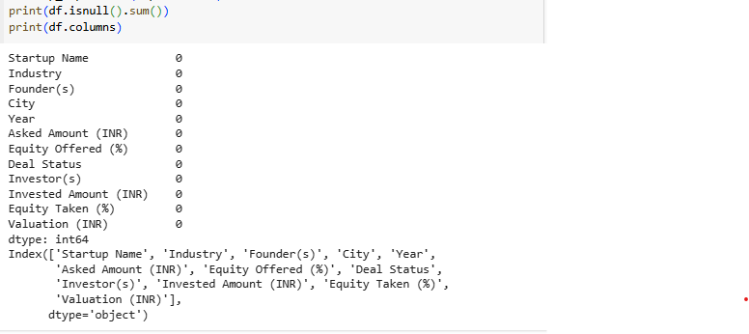

4.3 Feature Engineering :

# 3. Feature Engineering
df['Num_Founders'] = df['Founder(s)'].apply(lambda x: len(str(x).split(',')))
df['Funding Gap'] = df['Asked Amount (INR)'] - df['Invested Amount (INR)']
df['Funding % Fulfilled'] = df['Invested Amount (INR)'] / df['Asked Amount (INR)']
def equity_category(equity):
if equity < 10:
return 'Low'
elif equity <= 25:
return 'Medium'
else:
return 'High'

df['Equity Category'] = df['Equity Offered (%)'].apply(equity_category)
df['Deal_Success'] = df['Deal Status'].apply(lambda x: 1 if x == 'Yes' else 0)

4.4 Outlier Handling Using IQR:

# 4. Outlier Handling using IQR
# List of numeric columns to clean
num_cols = ['Asked Amount (INR)', 'Invested Amount (INR)', 'Valuation (INR)', 'Equity Offered (%)']

# Function to cap outliers using IQR
def cap_outliers_iqr(df, column):
Q1 = df[column].quantile(0.25)
Q3 = df[column].quantile(0.75)
IQR = Q3 - Q1
lower_bound = Q1 - 1.5 * IQR
upper_bound = Q3 + 1.5 * IQR
df[column] = df[column].clip(lower=lower_bound, upper=upper_bound)
return df
# Apply to all target columns
for col in num_cols:
df = cap_outliers_iqr(df, col)

4.5 Visualization & EDA :

# 5. Visualization / EDA
# Plot 1: Industry-wise Deal Status
plt.figure(figsize=(10, 6))
sns.countplot(data=df, x='Industry', hue='Deal Status')
plt.title("Industry-wise Deal Success")
plt.xticks(rotation=45)
plt.tight_layout()
plt.savefig("industry_success_count.png")
plt.show()
plt.close()

Output :
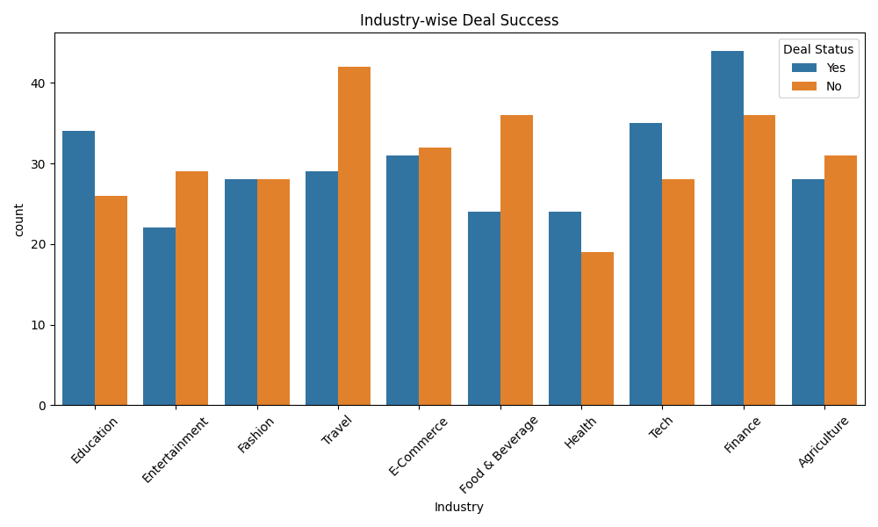

# Plot 2: Average Invested Amount by Industry

industry_funding = df.groupby('Industry')['Invested Amount (INR)'].mean().sort_values(ascending=False)
plt.figure(figsize=(10, 6))
industry_funding.plot(kind='bar', color='skyblue')
plt.ylabel("Average Invested Amount (INR)")
plt.title("Average Funding by Industry")
plt.xticks(rotation=45)
plt.tight_layout()
plt.savefig("avg_funding_by_industry.png")
plt.show()
plt.close()

Output :

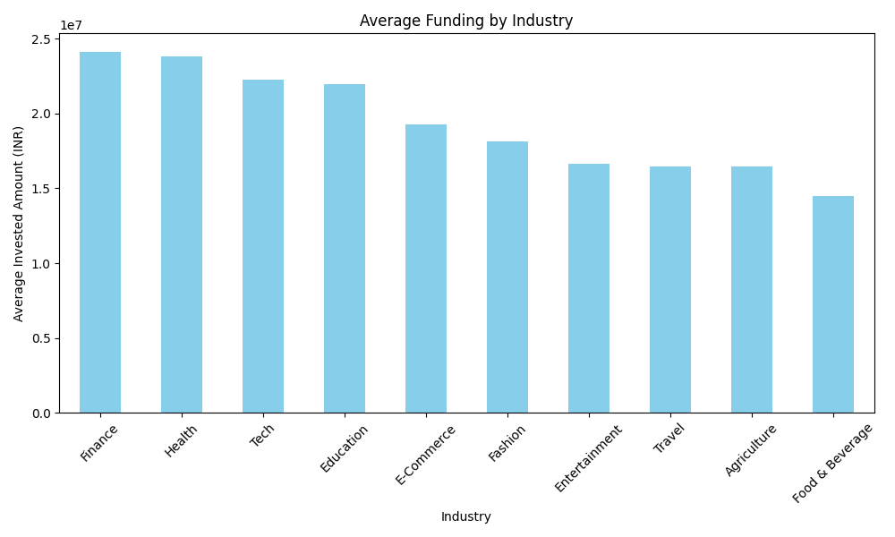

# Plot 3: Deal Success by Number of Founders

founders_success = df.groupby('Num_Founders')['Deal_Success'].mean()
plt.figure(figsize=(8, 5))
founders_success.plot(kind='line', marker='o', color='skyblue')
plt.ylabel("Deal Success Rate")
plt.xlabel("Number of Founders")
plt.title("Deal Success by Number of Founders")
plt.grid(True)
plt.tight_layout()
plt.savefig("founder_success_rate_line.png")
plt.show()
plt.close()
Output:
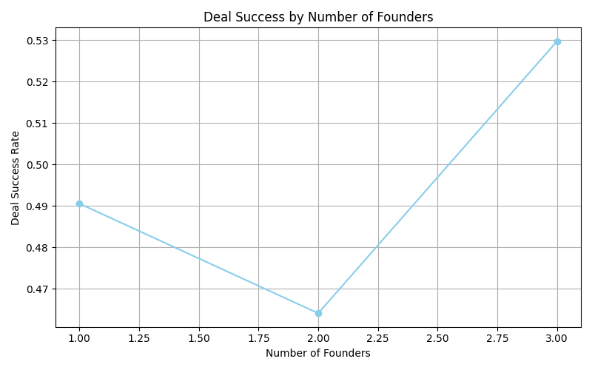

# Plot 4: Deal Status by Year

yearly_deals = df.groupby(['Year', 'Deal Status']).size().unstack().fillna(0)
plt.figure(figsize=(10, 6))
yearly_deals.plot(kind='bar', stacked=True, colormap='Paired')
plt.title("Deal Status by Year")
plt.ylabel("Number of Deals")
plt.tight_layout()
plt.savefig("yearly_deal_status.png")
plt.show()
plt.close()
Output:
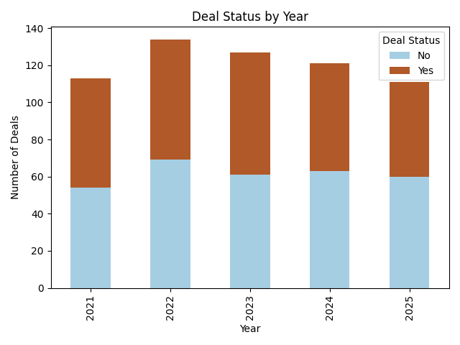

# Plot 5: Total Invested Amount by City

city_funding = df.groupby('City')['Invested Amount(INR)'].sum().sort_values(ascending=False)
plt.figure(figsize=(10, 6))
city_funding.plot(kind='bar', color='teal')
plt.ylabel("Total Invested Amount (INR)")
plt.title("Total Investment by City")
plt.xticks(rotation=45)
plt.tight_layout()
plt.savefig("city_funding_total.png")
plt.show()
plt.close()
Output:
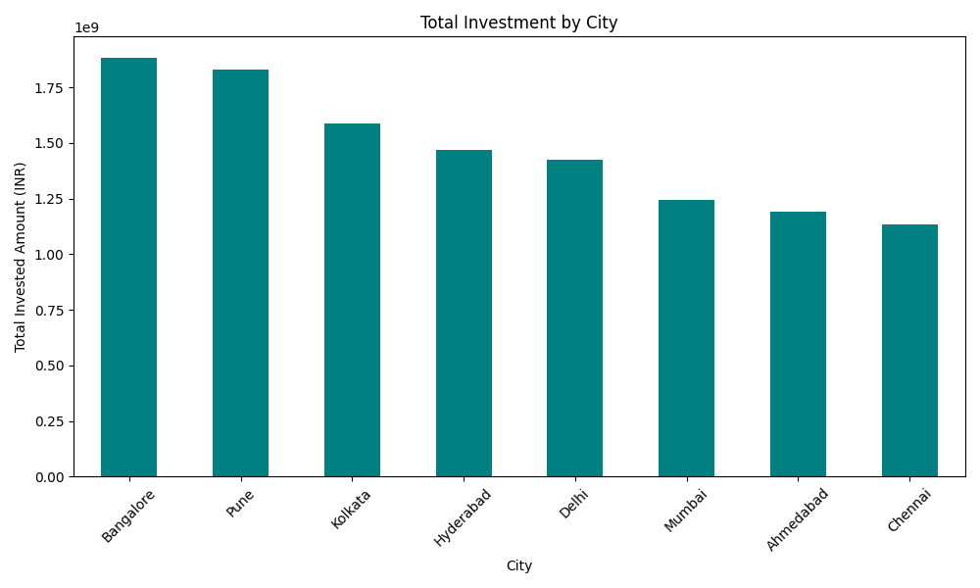

# Plot 6: Equity Offered vs Invested Amount (Successful Deals)

plt.figure(figsize=(10, 6))
sns.scatterplot(data=df[df['Deal_Success'] == 1],
x='Equity Offered (%)',
y='Invested Amount (INR)',
hue='Industry')
plt.title("Equity Offered vs Investment (Successful Deals)")
plt.tight_layout()
plt.savefig("equity_vs_investment.png")
plt.show()
plt.close()
Output:
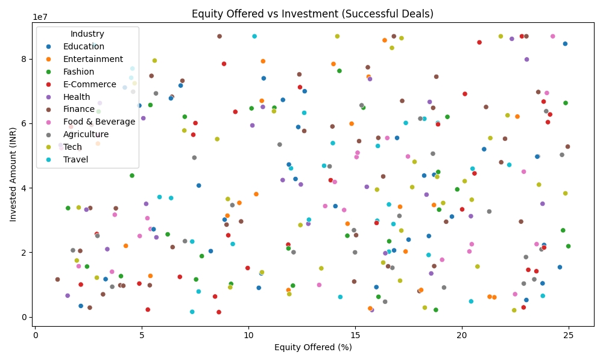

# Plot 7: Valuation vs Invested Amount (Successful Deals)

plt.figure(figsize=(10, 6))
df_sorted = df[df['Deal_Success'] == 1].sort_values(by='Valuation (INR)')
plt.plot(df_sorted['Valuation (INR)'], df_sorted['Invested Amount (INR)'], color='teal')
plt.xlabel('Valuation (INR)')
plt.ylabel('Invested Amount (INR)')
plt.title("Valuation vs Invested Amount (Line Chart)")
plt.tight_layout()
plt.savefig("valuation_vs_investment_line.png")
plt.show()
plt.close()
Output:
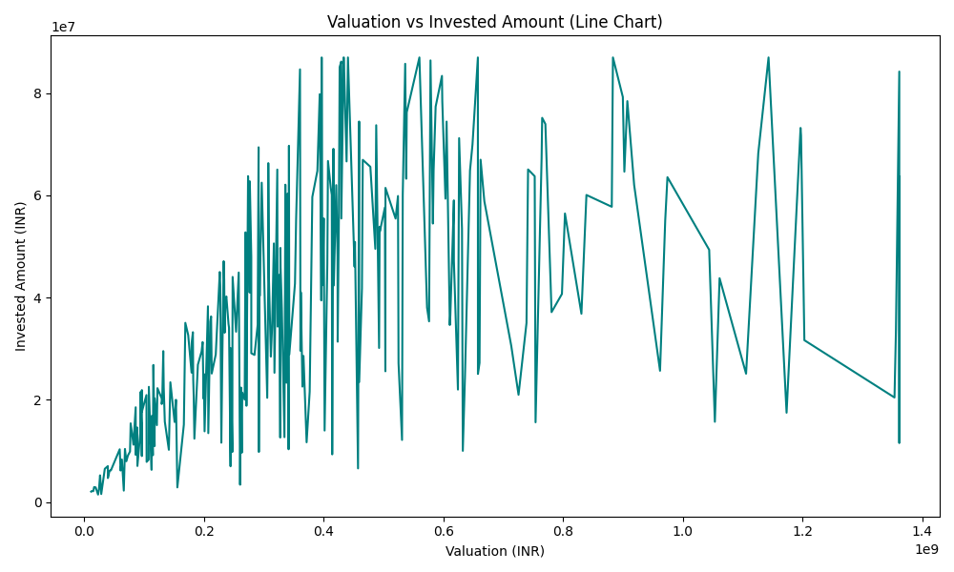

4.6 Model Training :

# 6. Model Training : Predict Invested Amount
# Use only successful deals
df_model = df[df['Deal_Success'] == 1].copy()
# Select features and target
features = ['Asked Amount (INR)', 'Valuation (INR)', 'Equity Offered (%)', 'Num_Founders']
df_model = df_model[features + ['Invested Amount (INR)']].dropna()
X = df_model[features]
y = df_model['Invested Amount (INR)']
# Split data
X_train, X_test, y_train, y_test = train_test_split(X, y, test_size=0.2, random_state=42)
# Train model
model = LinearRegression()
model.fit(X_train, y_train)
# Predict and evaluate
y_pred = model.predict(X_test)
r2 = r2_score(y_test, y_pred)
print("\nR² Score for Investment Prediction:", round(r2, 4))

Output:

R² Score for Investment Prediction: 0.9532

4.7 Export Cleaned Data :

# 7. Export Cleaned Data
df.to_csv("cleaned_sharktank_data.csv", index=False)
files.download("cleaned_sharktank_data.csv")

TABLEAU DASHBOARD:

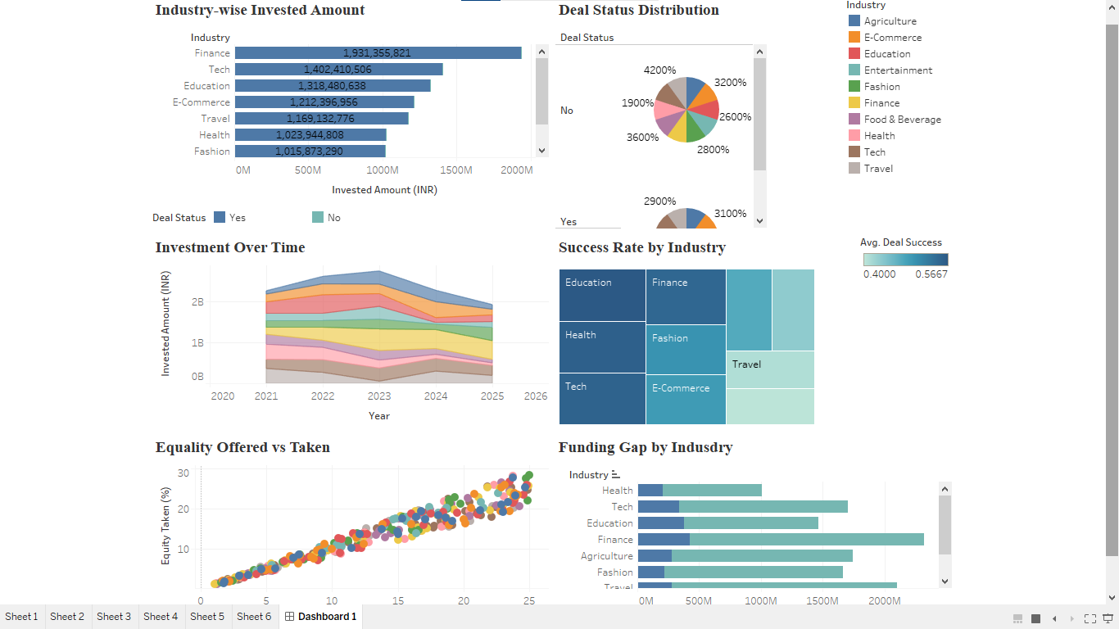

5. DEVELOPMENT :

5.1. Data Loading and Initial Exploration :

Objective: Understand the dataset's structure, content, and key characteristics before analysis.
Steps:
- Load Dataset:
Read the CSV file containing startup investment data inspired by Shark Tank India.
- Initial Exploration:
  - View the first few rows using .head() to understand the structure of records.
  - Generate summary statistics for numerical columns using .describe().
  - Identify missing values in each column using .isnull().sum().
  - Check the shape of the dataset using .shape to see the number of records and features.
  - Use .info() to view data types, column names, and non-null counts.
  - Explore category distributions such as Industry, City, and Deal Status using .value_counts().

5.2. Data Cleaning :
Objective: Ensure data quality by handling inconsistencies, formatting issues, and missing values to prepare the dataset for analysis.
Steps:
- Text Standardization:
  - Strip leading/trailing spaces and convert text to proper title case (e.g., Industry, City, Deal Status) for consistency.
- Handling Missing Values:
  - Replace missing values in the Investor(s) column with "No Deal" for unsuccessful pitches.
  - Fill remaining nulls (e.g., Valuation (INR)) using appropriate imputation or set to a default category like "Unknown".
- Currency Formatting:
  - Remove symbols such as ₹ and commas from financial columns like Asked Amount (INR), Invested Amount (INR), and Valuation (INR).
  - Convert these columns to numeric types using pd.to_numeric().
- Duplicate Handling:
  - Use .drop_duplicates() to remove any repeated entries in the dataset that could bias the analysis.
- Data Type Consistency:
  - Ensure that all columns have appropriate data types (e.g., numerical fields are floats or integers, categorical fields are strings).
- Column Verification:
  - Confirm the correctness and completeness of key columns such as Startup Name, Year, Investor(s), Founder(s), Equity Offered (%).

5.3. Feature Engineering :
Objective: Create new, meaningful variables that enhance the dataset and improve analytical and predictive modeling capabilities.
Steps:
- Number of Founders:
  - Derived from the Founder(s) column by counting the number of names separated by commas.
  - New column: Num_Founders.
- Funding Gap:
  - Calculated as the difference between the Asked Amount (INR) and Invested Amount (INR).
  - New column: Funding Gap.
- Funding Fulfillment %:
  - Computed as the ratio of Invested Amount (INR) to Asked Amount (INR).
  - New column: Funding % Fulfilled.
- Equity Category:
  - Classified the Equity Offered (%) into categories:
    - Low: <10%
    - Medium: 10–25%
    - High: >25%
  - New column: Equity Category.
- Deal Success Flag:
  - Converted the Deal Status (Yes/No) into a binary indicator for modeling purposes.
  - New column: Deal_Success (1 for Yes, 0 for No).

5.4. Outlier Handling :
Objective: Detect and treat outliers in numerical columns to improve model performance and ensure reliable analysis.
Steps:
- Target Columns for Outlier Treatment:
  - Asked Amount (INR)
  - Invested Amount (INR)
  - Valuation (INR)
  - Equity Offered (%)
- Method Used:
  - Interquartile Range (IQR) Method
    - Calculate Q1 (25th percentile) and Q3 (75th percentile).
    - Compute IQR = Q3 - Q1.
    - Determine lower and upper bounds:
      - Lower Bound = Q1 - 1.5 × IQR
      - Upper Bound = Q3 + 1.5 × IQR
    - Values outside these bounds are considered outliers and are capped to the nearest bound.
- Implementation:
  - A custom Python function was written to apply this method to each numeric column.
  - The function clipped values outside the IQR bounds to reduce skewness while retaining overall data distribution.
- Outcome:
  - Financial columns were stabilized, improving the quality of visualizations and performance of machine learning models.

5.5. Data Visualization / Exploratory Data Analysis (EDA) :
Objective: Discover patterns, trends, and relationships in the dataset using graphical techniques to support decision-making and modeling.
Steps:
- Categorical Analysis:
  - Industry-wise Deal Status:
    - Count plot showing how many startups in each industry received funding.
  - Deal Success by Number of Founders:
    - Bar plot to assess whether solo founders or teams were more successful.
  - Deal Status by Year:
    - Stacked bar chart to observe funding trends across different years.
  - City-wise Total Investment:
    - Bar chart to highlight regional hubs attracting the most investor capital.
- Numerical Analysis (for successful deals):
  - Equity Offered vs Invested Amount:
    - Scatter plot colored by industry to visualize negotiation patterns.
  - Valuation vs Invested Amount:
    - Line chart to examine the correlation between company valuation and investment size.

- Summary Visuals Created Using:
  - Matplotlib & Seaborn in Python
  - Visualizations were saved as .png files for documentation and reporting.

5.6. Model Building and Evaluation :
Objective: Build a predictive model to estimate the invested amount for successful startup deals and evaluate its performance.
Steps:
- Data Preparation for Modeling:
  - Filtered the dataset to include only successful deals (Deal_Success = 1).
  - Selected relevant features:
    - Asked Amount (INR)
    - Valuation (INR)
    - Equity Offered (%)
    - Num_Founders
  - Target variable:
    - Invested Amount (INR)
- Train-Test Split:
  - Divided the data into training and testing sets using an 80:20 ratio.
  - Used train_test_split() from Scikit-learn with a fixed random state for reproducibility.
- Model Used:
  - Linear Regression from Scikit-learn.
  - Trained the model on the training set using .fit() method.
- Prediction and Evaluation:
  - Predicted investment values on the test set.
  - Evaluated performance using R² Score to measure the proportion of variance explained by the model.
  - Higher R² indicates better predictive accuracy.
- Result:
  - The model provided a reasonable estimate of investment amounts based on startup features.
  - Findings support the feasibility of using machine learning in early-stage startup funding analysis.
5.7. Dashboarding with Tableau :
Objective: Show startup funding insights in a clear and interactive way using Tableau.
Steps:
- The cleaned data was saved as a CSV file and imported into Tableau.
- Different charts and dashboards were created to explore:
  - Which industries got the most funding
  - Which cities received the highest investments
  - Year-wise deal success and failure
  - Relationship between equity, valuation, and investment
- Filters were added to let users explore data by industry, year, city, and deal status.
- Key metrics like total deals, average investment, and deal success rate were displayed.
- The dashboard helped explain funding trends to others in a simple and visual way.
6. DEPLOYMENT :
Although this project was developed in an academic setting, the deployment process can be adapted for real-world investment analysis platforms. The trained machine learning model can be integrated into a startup evaluation tool used by investors, incubators, or venture capital firms to predict likely investment amounts for new startup pitches.
The Tableau dashboards can be hosted on Tableau Public or Tableau Server, allowing interactive exploration of startup trends, funding patterns, and deal success factors by decision-makers and analysts.
With regular updates to the startup dataset, the model can be retrained periodically to maintain prediction accuracy and reflect the latest funding behaviours. This setup can assist investors in making data-driven decisions, while also helping startups understand how factors like valuation, equity, and team size affect investment outcomes.
Additionally, automated insights or alerts can be developed to highlight high-potential startups based on model predictions, aiding in proactive deal screening and portfolio management.

V. SUMMARY:
In summary, the Shark Tank Startup Investment Analysis project focused on understanding the key factors that influence startup funding decisions using data inspired by Shark Tank India. The project involved data cleaning, feature engineering, outlier handling, and exploratory data analysis using Python libraries like Pandas, Matplotlib, and Seaborn. A linear regression model was developed to predict the invested amount in successful deals based on features such as valuation, equity offered, and number of founders. Tableau was used to create interactive dashboards that visualized investment trends across industries, cities, and founder dynamics. This project demonstrated how data analytics and machine learning can provide actionable insights for investors and entrepreneurs, and how visualization tools can support effective, data-driven decision-making.

VI . CONCLUSION:
This project successfully demonstrated how data analytics and machine learning can be applied to analyze and predict startup investment behaviour. By exploring historical data from Shark Tank India, key factors such as valuation, equity offered, industry type, and founder count were identified as major influences on funding outcomes. The implementation of a linear regression model allowed for accurate prediction of invested amounts in successful deals, while Tableau dashboards helped visualize funding trends across industries, cities, and time periods. These insights provide valuable guidance for both startups and investors, supporting data-driven decision-making in the entrepreneurial ecosystem. Overall, the project highlights the power of analytics in understanding investment dynamics and has strengthened my skills in data preprocessing, feature engineering, model evaluation, and interactive visualization—laying a strong foundation for solving real-world business challenges through data science.

VII . REFERENCES:
The following resources, tools, and datasets were used during the completion of the project:
Books & Articles
- McKinney, W. (2018). Python for Data Analysis: Data Wrangling with Pandas, NumPy, and IPython (2nd ed.). O’Reilly Media.
- Géron, A. (2019). Hands-On Machine Learning with Scikit-Learn, Keras, and TensorFlow (2nd ed.). O’Reilly Media.
Websites
- Google Research. (2024). Google Colaboratory (Colab). Retrieved from https://colab.research.google.com
- Tableau Software. (2024). Tableau Desktop Manual. Retrieved from https://www.tableau.com
- Shark Tank India Startup Investment Dataset. Available on Kaggle: https://www.kaggle.com
- Scikit-learn: Machine Learning in Python – https://scikit-learn.org
- Seaborn: Statistical Data Visualization — https://seaborn.pydata.org
- Pandas Documentation – https://pandas.pydata.org

